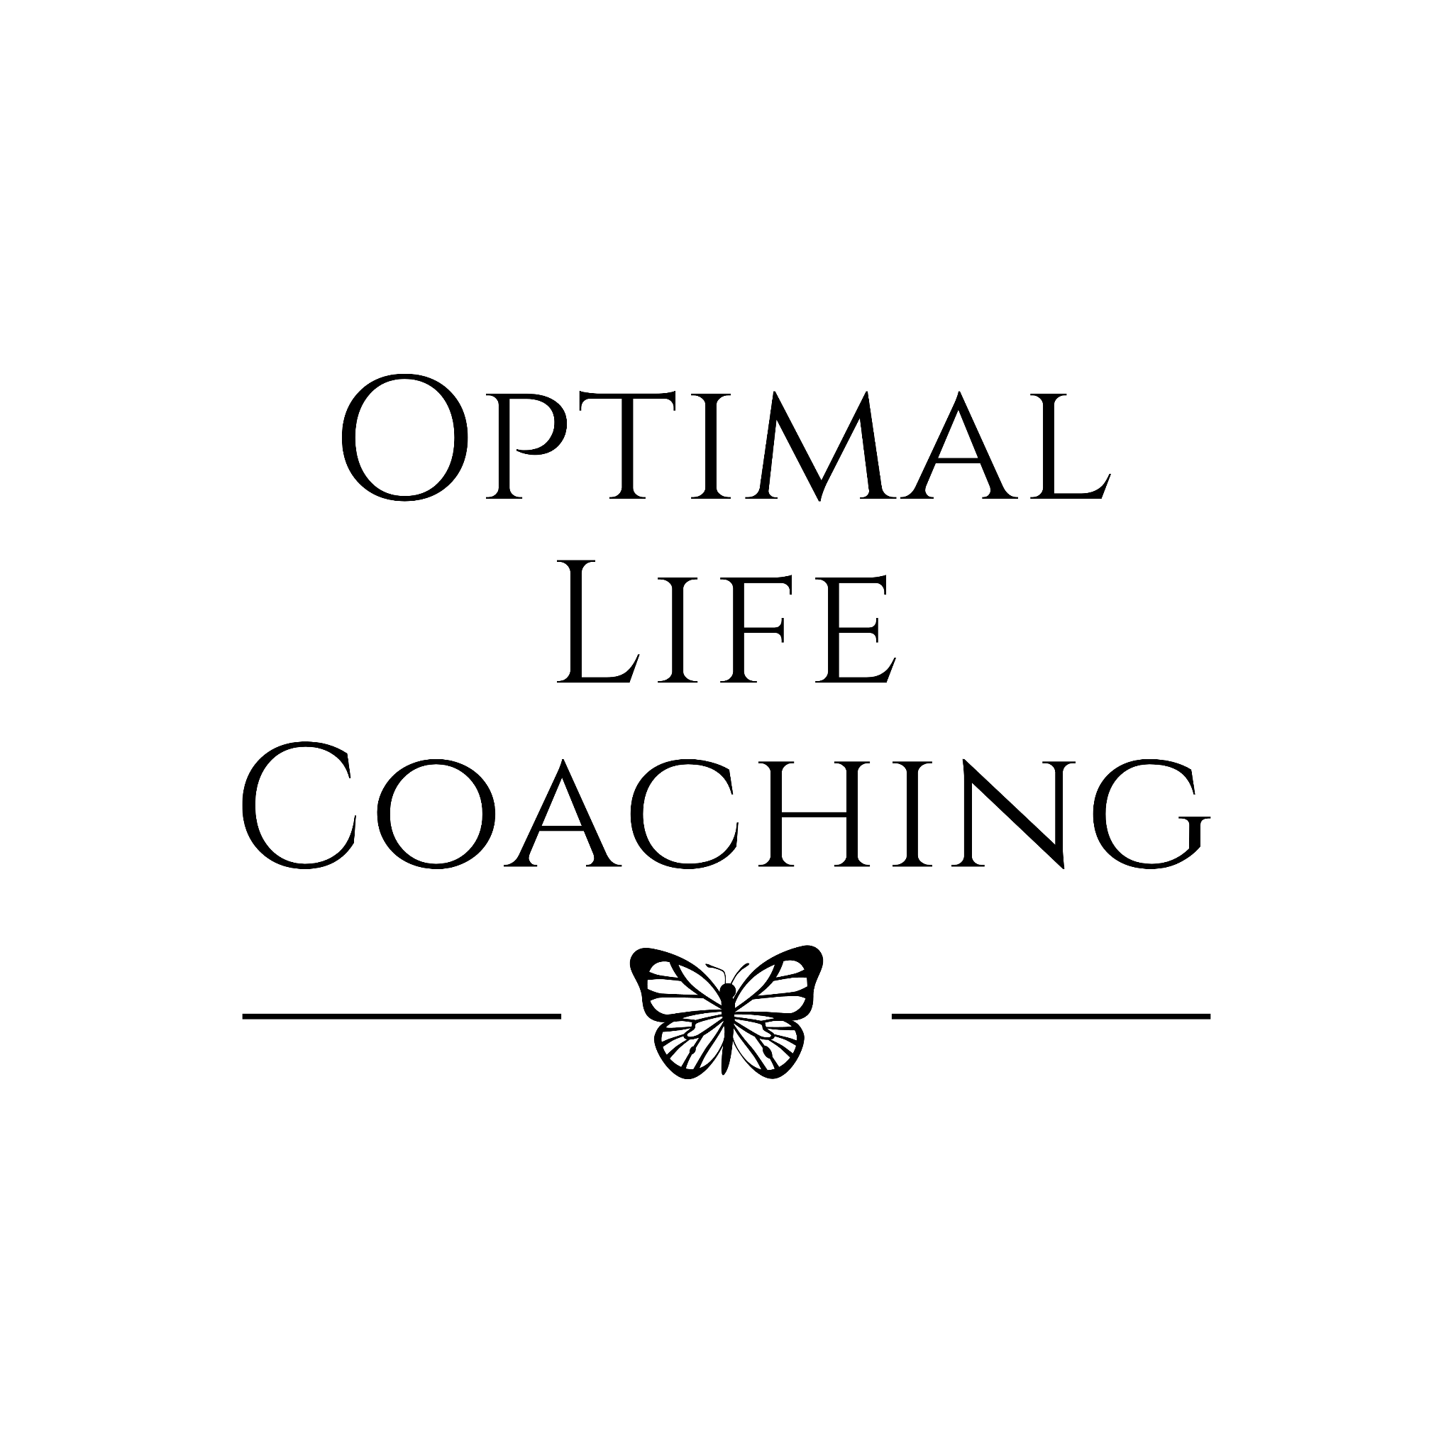
“Interview With Life Coach Denise Donohue”

How long have you been doing what you do and how did you get started?

I have worked as a school counselor for the past twenty five years, and most recently I have been working with students that experience crisis; high social emotional needs. As you can imagine, being in a high stress job like such, I became unhealthy both physically and mentally.

In 2021, I was introduced to a health coaching program and got myself a health coach. We worked together and I shed 65 lbs in the upcoming year. This weightloss left me feeling healthy, energized, and let's face it…sexy as hell. I started to gain my confidence back, which I now label as my “Mojo.”

This new found confidence gave me the motivation to go out and help other women that struggle with their confidence, their mojo, and empower them to become unstoppable. This vision I had to transform women led me to enrolling in a Life Coaching program where I could fine tune my counseling background and create a mind-blowing transformation program.

Although my life coaching is fairly new, my experience from working in the mental health field has given me the skills to implement proven methods that help change mindsets, develop healthier habits, and to have unstoppable confidence…a Confidence Queen.

What kinds of clients do you work with?
I work with all types of clientele including teenagers. But my passion and my true desire is to continue to transform women.

Being a woman myself, and understanding how a lack of confidence can hold you back from achieving all of the desires and dreams we have set out for ourselves, it is important now more than ever to help women see their worth. Tired of hearing the “this is just what motherhood looks like,” “I’m pretty sure this is what it is like to get old,” or “I’ll never get the promotion so why try?” These are the voices we tell ourselves because we hit the glass ceiling.

You know the glass ceiling. The invisible barrier that prevents women from advancing in life…from becoming their true self. The glass ceiling effect can impact all aspects of your life, not just your confidence. It impacts…

- Anxiety
- Self esteem
- Digestion
- Weight Loss
- Blood pressure
- Metabolism
- Energy levels
- Irritability/mood swings
- Sadness
- Sleep

The list goes on. Although, both men and women may experience the glass ceiling effect, historically, women are impacted more often and more intensely. That's why transforming women is my absolute mission in my life coaching work.

How are you different from other life coaches?

Most life coaches give you a checklist of what to do and what not to do. For women who struggle with confidence, if this approach worked, it would have worked already. But giving a client a list of things to do will not help build confidence. Because a lack of confidence does not have to just do with the choices we make on a daily basis…

It has to do with our inability to cope with the stresses of day-to-day life. It has to do with putting other people’s needs ahead of our own. It has to do with the inner voice and the negative thinking patterns we are accustomed to telling ourselves. We are our own worst critic.

So first and foremost my coaching is about transforming beliefs and mindsets so that my clients can be present with themselves and their lives in a whole new way. I created step-by-step guidelines around healthy ways to change our mindset, change habits, and incorporate a healthy lifestyle.

Something else that makes me different from other coaches is that I hold you accountable to your goals throughout the week. I believe that a healthy lifestyle change is not just embedded in our sessions, but should include friendly reminders throughout the week…which includes weekly affirmations.

And because I lived through the transformation…from being anxious, moody, suffering from low self esteem, and feeling unhealthy both physically and mentally, to now feeling confident and unstoppable…I’ve become an expert on the topic of Mojo.

What type of personality do you work best with and what is expected of me?

My Total Confidence Queen Transformation programs were created for women who are absolutely ready and fully committed to having a new relationship with their mind, body, and soul. Putting an end to the glass ceiling effect and getting everything that you desire in life.

These programs were created for you to put systems around mind and body in place in 30, 60, and 90 days, which will eventually lead you to having an experience of peace and even JOY in your body and with your mindset creating new healthy habits that override negative self talk.

Consider what you’ll do with me to be a transformational experience where you’re consistently taking action. No more worrying that you’ll never find something that works for you; you’ll open up to a very different way of thinking and full support while you achieve this incredibly exciting goal: ending a war with the negative mindset and experiencing a Total Confidence Queen Transformation.

Who does this program NOT work for?

I only have openings for 2 new clients per month in my schedule, so please know I’m very selective about who I work with, choosing to (gently) turn away people who aren’t suited for my program and won’t get the results they would have invested in. (It wouldn’t be fair to them.)

The Total Confidence Queen Transformation system is NOT for those who aren’t ready to commit financially to their transformation, and it is NOT for those who are not up for the challenge of following through on their weekly goals. In fact, all that is needed throughout the weeks between our sessions is 1% more than you gave the week before.

Another kind of person this program would not be suitable for is the skeptic, as well as individuals who consistently don’t show up to sessions or make excuses in order to keep putting themselves and their physical and mental wellness last on the list of priorities. If you are willing to try something new, give 1% percent effort, and make your physical and mental wellness a priority, then this is your program. If not, I gently and respectfully ask that you not schedule our initial conversation and I hope you understand why. We’ll probably just not work well together and I wouldn’t want you to waste your time or money.

What exactly is your system and what does it include?

The Total Confidence Queen Transformation system is a holistic journey that involves mind, body and soul healing. We’re going to cover all things mind and body using the “6W Questions” - remember those from 6th grade when you learned about journalism?
The “6W Questions” are:

• What
• When
• How
• Where
• Why
• Who

The “6W Questions” constitute a simple formula for getting the complete story on any subject. When I’m working with you as my client, we are definitely looking for the COMPLETE story around mindset and body. That’s why, in Total Confidence Queen Transformation, I’ll walk you step-by-step through…

• What to do when negative self-talk arises
• When to best practice new habits
• How to incorporate high energy foods for mental clarity
• Where to insert more confidence in your life
And most importantly…
• Why you have negative thinking patterns
• Who you are being when you change your thought process

Does this really work?

Yes! The result of our work is an approach to mind and body that has you feeling peaceful, powerful and on purpose, maybe for the first time in your life. Be sure to read the Success Stories document attached in your “Prepping For Your Session” email to read the stories of women just like you who have experienced this kind of result.

What results can I expect?

You can expect to:
• Create a vision for what your Total Confidence Queen Transformation looks like
• Anchor into your Big Why (this is the real reason why making this change matters!)
• Clear clutter (emotional and physical) from your life so you can make space for the new you
• Practice proven methods to help change negative thinking patterns

Optimize your lifestyle by:
• Discovering all the key elements that feed your body and your soul, like:
• Sleep & Movement
• Food & hydration
• Love & Sex
• Fun & Play

How quickly can I expect results?
Your transformation begins the second you say “YES” and continues every day throughout your 90-day experience and beyond.

How can I guarantee myself that I will get Confidence Queen results?

If you’ve tried things and failed in the past, chances are good that you didn’t have the right support, the right system or the right accountability In Total Confidence Queen Transformation, you’ll get all of these. Part of the reason for the significant investment in this experience is to ensure that you show up for yourself like never before.

Will I recover the investment I put into this coaching program?

If you add up everything you’ve spent over the years on health visits and other programs and all of the money lost from a lack of motivation and self confidence, how much would that be? If things don’t change, how much would you spend in the coming years searching for a solution? For most of my clients, the answer to both questions is A LOT.

I want you to stop reading for just one moment to ask yourself, “What is a new relationship to my mind and my body worth to me?” The information and skills you learn - and the personal transformation you make - with The Total Confidence Queen Transformation will be with you forever, transforming your physical and mental wellness and your life in so many ways.

OK, I know you’re the one I want to work with. How do we get started?

Congratulations on making a decision for a totally new experience of mindset and body! I’m honored and excited to be your guide on this journey! Here’s how we get started:

• During our initial conversation, you can officially enroll in the Total Confidence Queen Transformation
• I’ll walk you through how to make the investment (I accept all major credit cards, as well as checks, and Venmo so processing the investment will be easy)
• We’ll choose a recurring day of the week and time for your sessions
• These sessions should be considered a sacred time - they are first priority because YOU are first priority
• Sessions will occur once per week for 90 days (with two bonus sessions during the 90 days as needed)
• I’ll send you a “Welcome Email” that includes a Coaching Program Agreement (you’ll sign this agreement before our first session)
• You’ll watch your front porch for a special welcome box that I’ll ship to you with a gift that will help enhance your Confidence Queen experience

Tackling all the above is a lot on our own and often overwhelming to the point that it is easier to stay where we are. Coaching is a process that is facilitated in a specific way so you can be different, without having to think about being different. The first step is raising awareness about what we really desire for ourselves and our lives.

Do people ever renew and continue working with you?

Yes, about 1/3 of my clients want to continue the work - they love the on-going support and stretch. If that’s something you’d like, I’ll share how you can do that as we get closer to the completion of your first Confidence Queen experience.

OK, I’m ready to do this for myself, but I have a couple of additional questions. Can we address them in our Breakthrough Session?

Absolutely. We’ll be sure to cover all of your questions, plus the Breakthrough Session will give you firsthand experience of what it would feel to have a powerful coach and mentor in your corner.

